TEST Session log:

CREATE TABLE Customer_data (USER_ID VARCHAR(10), Firstname VARCHAR(10), Lastname VARCHAR(10), Phone_num VARCHAR(16), account_balance INTEGER) PRIMARY KEY (USER_ID);

INSERT INTO Customer_data VALUES FROM ("000000001", "Michale", "White", "979-445-2234", 12343);

INSERT INTO Customer_data VALUES FROM ("000000002", "Nichole", "Black", "312-465-2134", 10000);

INSERT INTO Customer_data VALUES FROM ("000000003", "Allen", "Green", "969-986-2634", 1982);

INSERT INTO Customer_data VALUES FROM ("000000004", "Robin", "Miller", "978-112-2234", 6754);

INSERT INTO Customer_data VALUES FROM ("000000005", "Arya", "Bach", "221-893-1243", 2000);

INSERT INTO Customer_data VALUES FROM ("000000006", "Jason", "Stark", "113-445-9865", 4536);

INSERT INTO Customer_data VALUES FROM ("000000007", "Johnny", "Shannon", "126-278-2865", 2341);

INSERT INTO Customer_data VALUES FROM ("000000008", "John", "Shannon", "126-278-2865", 2000);

SHOW Customer_data;

deleted_Customer <- DELETE FROM Customer_data WHERE Firstname == "Robin";

UPDATE Customer_data SET account_balance = account_balance + 100 WHERE account_balance < 10;

selected_Customer <- SELECT FROM Customer_data WHERE Firstname == "Allen" && Phone_num == "978-112-2234";

selected_negativeBlance_Customer <- SELECT FROM Customer_data WHERE account_balance < 0;

WRITE Customer_data;

CLOSE Customer_data;

EXIT;

//DVD datas

CREATE TABLE DVD (title VARCHAR(20), kind VARCHAR(10), year INTEGER, DVDid VARCHAR(6), inventoryNumber INTEGER) PRIMARY KEY (DVDid);

INSERT INTO DVD VALUES FROM ("Pacific Rim", "SciFi", 2006, "S000", 100);

INSERT INTO DVD VALUES FROM ("Serenity", "SciFi", 2006, "S001", 107);

INSERT INTO DVD VALUES FROM ("Godzilla", "SciFi", 2014, "S002", 109);

INSERT INTO DVD VALUES FROM ("Mockingbird", "Drama", 1962, "D000", 101);

INSERT INTO DVD VALUES FROM ("Schindler", "Drama", 1993, "D002", 104);

INSERT INTO DVD VALUES FROM ("Northwest", "Adventure", 1959, "A000", 200);

INSERT INTO DVD VALUES FROM ("Idiana Jones", "Adventure", 1984, "A001", 103);

INSERT INTO DVD VALUES FROM ("X-Men", "Adventure", 2014, "A002", 108);

SHOW DVD;

UPDATE DVD SET year = 2005 WHERE title == "Serenity";

UPDATE DVD SET year = 2014 WHERE title == "Pacific Rim";

WRITE DVD;

OPEN DVD;

project_test <- project (title, kind, DVDid, inventoryNumber) DVD;

SHOW project_test;

INSERT INTO DVD VALUES FROM ("Old Boy", "Drama", 2003, "D003", 005);

INSERT INTO DVD VALUES FROM ("Kagemusha", "Drama", 1980, "D001", 002);

SHOW DVD;

adventure <- select (kind == "Adventure") DVD;

drama_or_adventure <- adventure + (select (kind == "Drama") DVD);

SHOW drama_or_adventure;

UPDATE DVD SET (kind = "Thriller", DVDid = "T000") WHERE title == "Old Boy";

thriller_films <- select (kind == "Thriller") DVD;

SHOW thriller_films;

scifi <- select (kind == "SciFi") DVD;

thrillers <- select (kind == "Thriller") DVD;

rename_test <- rename (title, kind, year, DVDid, inventoryNum) DVD;

SHOW rename_test;

scifi_and_thriller <- scifi + thrillers;

drama_films <- select (kind == "Drama") DVD;

SHOW drama_films;

recent_adventure_films <- select (kind == "Adventure") (select (year > 2000) DVD);

SHOW recent_films;

DELETE FROM DVD WHERE (kind == "Adventure");

SHOW DVD;

advanced_query <- project (title) (select (kind == "Thriller") (drama_films * thrillers));

classic_films <- select (year <= 1980) DVD;

SHOW classic_films;

SHOW DVD;

product <- scifi * thrillers;

difference <- drama_films - scifi;

CLOSE DVD;

EXIT;

//rental log

CREATE TABLE Rental_log (USER_ID VARCHAR(10), inventoryNum INTEGER, check_out_date VARCHAR(16)) PRIMARY KEY (USER_ID, inventoryNum, check_out_date);

INSERT INTO Rental_log VALUES FROM ("000000001", 101, "12/12/2013", "06/12/2014");

INSERT INTO Rental_log VALUES FROM ("000000005", 107, "02/23/2014", "08/23/2014");

INSERT INTO Rental_log VALUES FROM ("000000004", 200, "03/02/2014", "09/12/2014");

INSERT INTO Rental_log VALUES FROM ("000000003", 100, "12/12/2013", "06/12/2014");

INSERT INTO Rental_log VALUES FROM ("000000006", 109, "02/28/2014", "08/28/2014");

INSERT INTO Rental_log VALUES FROM ("000000002", 108, "04/02/2014", "10/12/2014");

rental_big_inventoryNum <- select (inventoryNum > 150) Rental_log;

rental_1 <- select (USER_ID == "000000006" || USER_ID == "000000002") Rental_log;

rental_2 <- rename (userid) (project (USER_ID) Rental_log);

SHOW Rental_log;

WRITE Rental_log;

CLOSE Rental-log;

EXIT;

SCREEN SHOTs for customers:

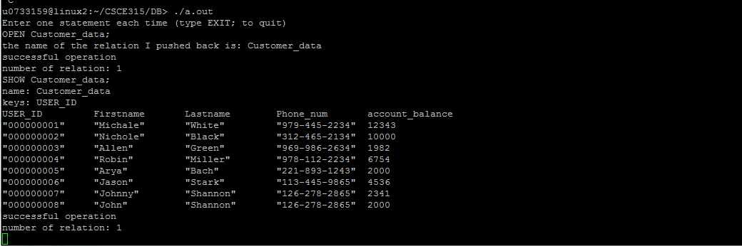

DVD screen shots:

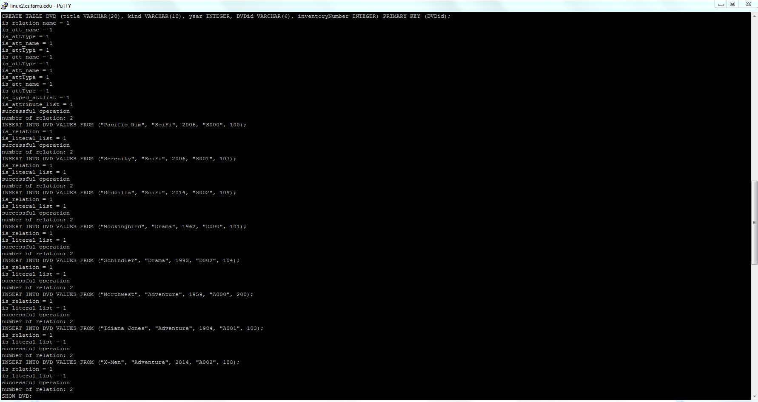

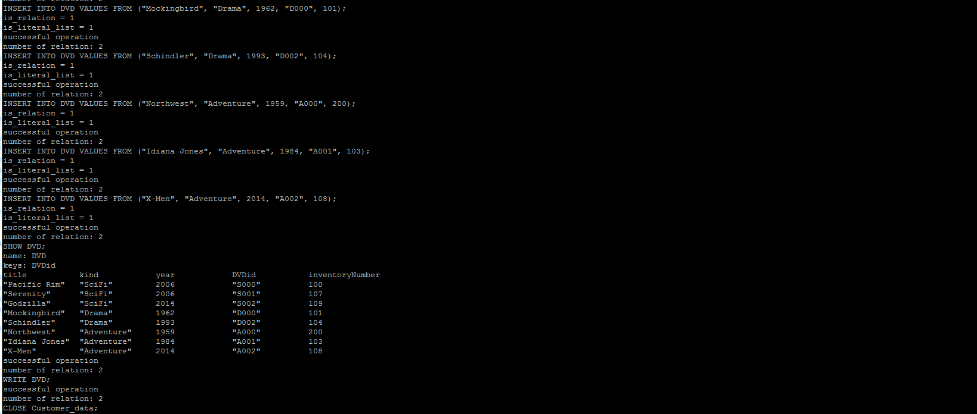

Rental_log:

